INFORMATION BROCHURE

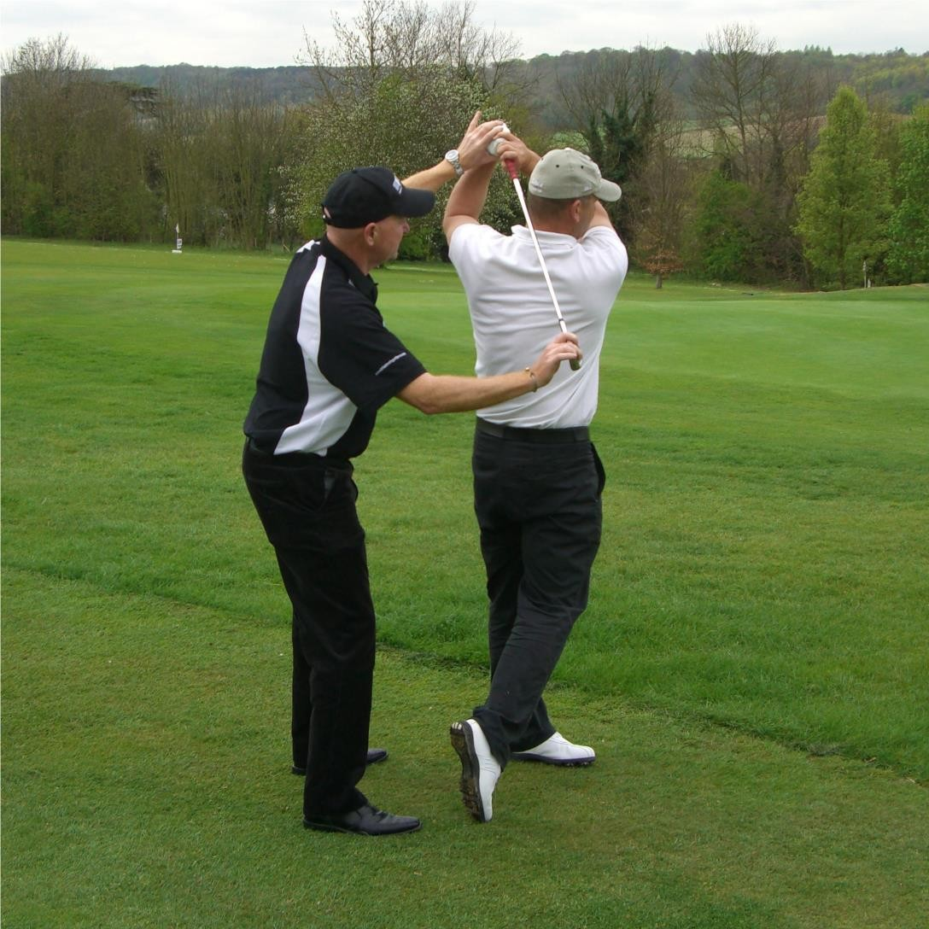

MAKE YOUR PASSION YOUR PROFESSION
FULLY RECOGNISED TUTOR TRAINING PROGRAMS

Business Achievement Award for Outstanding Services to Sports Development 2009

Dear Sir/Madam

Thank you for your interest in the opportunity to become a qualified golf teacher. Established since 1992, providing amateur and professional golfers the opportunity to become a qualified golf teacher. Our program is acclaimed for its professionalism and the standards it provides in helping to train future golf instructors.

The EGTF diploma course is quality assured against the standards outlined in the course information and is recognised by ABC Awards, a nationally recognised Awarding Association in the UK.

I have pleasure in enclosing the information on our tutor training program, and I look forward to welcoming you on one of our residential diploma training courses in the near future.

If there is anything you would like to discuss regarding the venue or the course itself, please do not hesitate to contact us at head office.
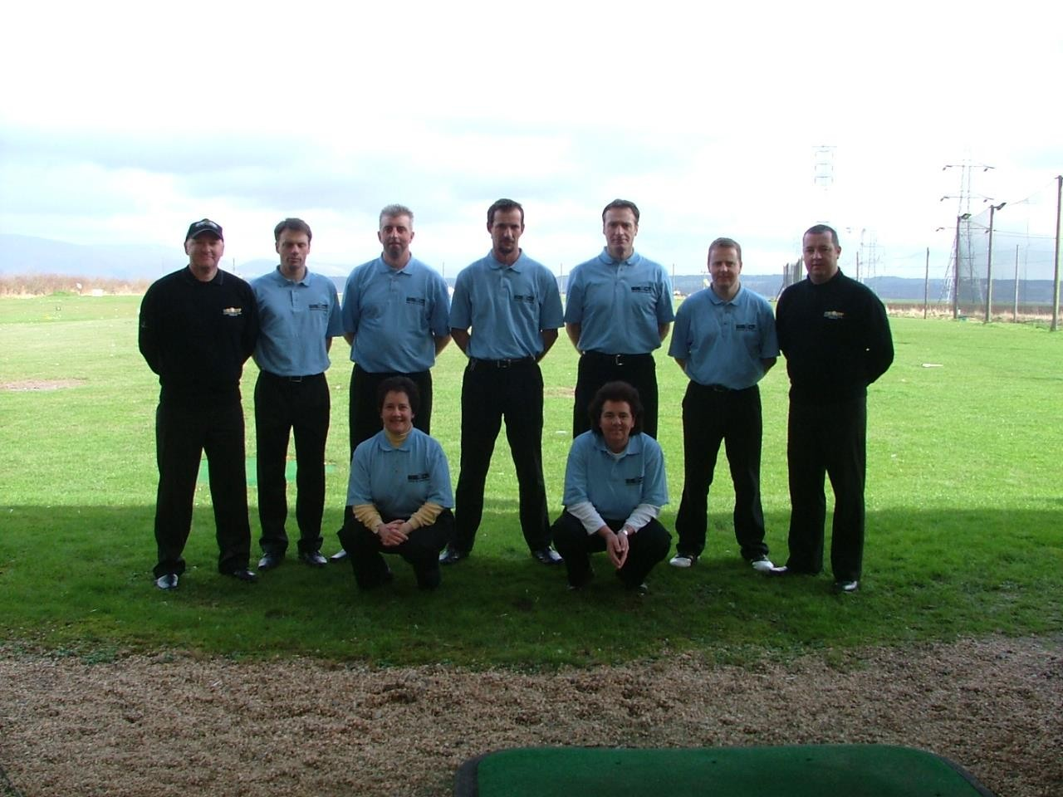

4 Marionsleigh, 37 Blenheim Road, Minehead, Somerset. TA24 5QA TEL: 01643 706010 EMAIL: mail@egtf.co.uk
WEBSITE: www.egtf.co.uk

The EGTF Diploma in Golf Teaching

The Course consists of lectures, practical work on the range, and examinations that will provide everyone with all the necessary basic tools and information to give a professional golf lesson.

Course Content:
• Course introduction and EGTF history
• Teaching psychology
• Teaching total beginners
• The Set up – Grip/Aim/Alignment/Stance/Posture
• Teaching positions
• Backswing
• Forwardswing
• Video analysis
• Putting
• Chipping
• Pitching
• Sand play
• Teaching children
• Preparation of a professional golf lesson

To gain the EGTF teaching diploma the following assessments must be completed:

Rules Test - To be completed before the course starts.

The rules test ensures a good understanding of the rule book and how to use it

Written Theory Test – On EGTF methods and theories

A written workbook to be completed, this is based on information received during the course of week.

Demonstration ability Test – To show your ability to effectively demonstrate various skills to pupils

Teaching Test – To ensure excellent standards of teaching are demonstrated. Two lessons are given to members of the general public.

Upon Course Completion

Successful candidates will be awarded with a Professional Golf Teaching Diploma and Full EGTF Membership Card. This will cover your EGTF membership till the end of the year you passed.

Course Dates

European Golf Teachers Federation- Diploma Courses 2022

- March 20th – 25th, Manor House & Ashbury Hotel, Devon, UK
- May 22nd – 27th, Manor House & Ashbury Hotel, Devon, UK
- July 10th – 15th, Manor House & Ashbury Hotel, UK
- September 11th – 16th Manor House & Ashbury Hotel, UK

European Golf Teachers Federation- Masters Diploma Course 2022

Dates are yet to be finalised please contact us for more information.

Further Education

We also offer Refresher Courses, Advanced Learning Seminars and Master
Teaching Courses whereby qualified members are upgraded with the latest golf teaching ideas and technology. These Courses are part of our Continual Professional Development program that has been introduced for the benefit of our members. This program is practical as well as theoretical, and enhances our members reputations as leaders in the field of golf teaching and education.

Photos
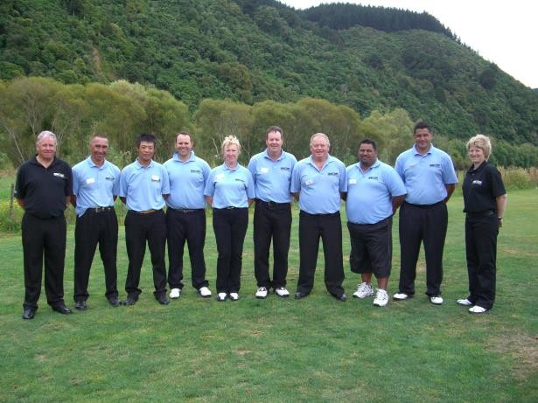
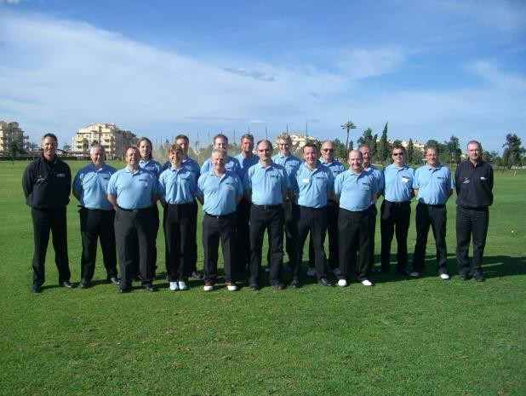
Spain New Zealand

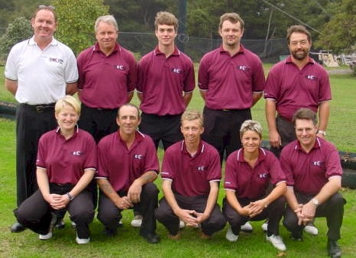
England

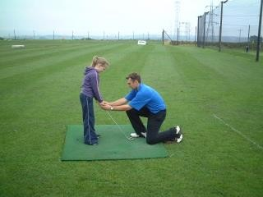
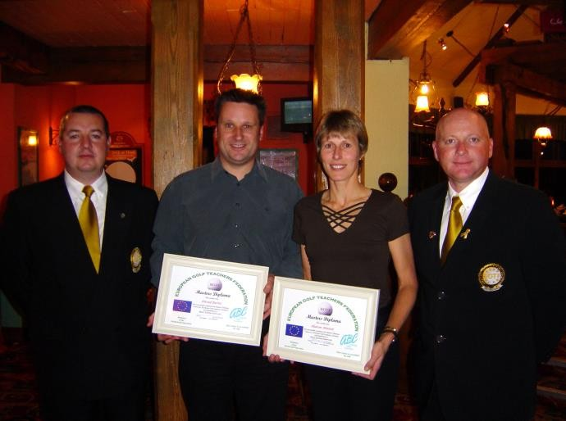
England

E.G.T.F. RESIDENTIAL DIPLOMA TRAINING COURSE

The Manor House & Ashbury Hotel
Oakhampton, Devon

COST OF A 6 DAY DIPLOMA COURSE

£1,495

We can only hold a definite place on the Course date of your choice, with a deposit of £350

FEES INCLUDE
- Diploma course instruction
- Personal copy of E.G.T.F Training Manual & Literature
- E.G.T.F Polo Shirt
- E.G.T.F. Teaching Insurance to the end of the year after the course
- Gala Presentation & Diplomas
- Accommodation for 5 nights (Based on Twin Sharing)
- Full Board (Breakfast, Lunch and Dinner)
- Full Use of the Hotels Extensive Facilities
- Green Fees and Range Balls
- Buggy Hire
- Free EGTF Membership Subscription to the end of the year after Diploma Course
- All gratuities & tax

* Other Rooming options available contact head office to find out more

Head Office - 01643 706010

TESTIMONIALS

“The EGTF Course I completed recently was well above my expectations. I have achieved a better understanding of the game and how to teach it, along with increased knowledge of technology. There was so much good information on it, and Bill Abbott delivered everything in a highly professional manner. Worth every penny!”

Sergeant Major Karl Chappelle, EGTF Pro
Germany

“I just wanted to express my thanks to Bill and Stewart for making the EGTF Diploma Course such a fun and informative week. I learnt a lot about teaching and the golf swing which will be most beneficial for me personally and in my coaching. Your enthusiasm to help those to become better teachers and to pass the Course was fantastic and it has given me a lot of confidence to want to develop my skills further.
It is great to be part of an organisation that is willing to encourage their members at every opportunity. I was thrilled to get my Diploma and punched the air when I got back to my hotel room, as if I had won a tournament.”

Alison Nicholas, MBE, EGTF Pro
US Open Champion and 6 times Solheim Cup player

"Having started golf at a young age, I reached a scratch handicap and represented my County for more than twenty years. During this time I played in numerous National and Regional events and became involved administratively in the running of both Club and County golf. I have also been involved in the golf industry and have worked for more than ten years for a number of golf companies and concluded this part of my career by representing Cobra which became part of the Acushnet brand (including Titleist Footjoy).
Since obtaining my teaching qualification with the EGTF I have moved to Spain, where I have worked for the last three years. I currently work at Oliva Nova Golf and Beach Hotel, Valencia, which is a 5 star resort designed by Seve Ballesteros which hosts many Spanish events from the OKI tour, and Regional Championships.
At Oliva we have a Golf Academy, Junior Schools and teach golfers of all standards from all over Europe. At present I currently write instructional articles for two newspapers on the Costa Blanca and I am also a Staff Instructor on Diploma Courses for the EGTF.
Without my teaching qualification I would not have been able to teach and pass on my experience and knowledge to other golfers. I continue to recommend the EGTF to many aspiring professionals."

Paul Tolley, EGTF Master Teaching Pro
Oliva Nova Golf Hotel, Spain

Thank you to you and your excellent team for such an interesting, challenging and stimulating week. I would recommend the course to anybody with a serious interest in improving their own and others’ games. As well as having a fantastic week with a great group of people, I learned an enormous amount and am already experiencing a big improvement in pupils’ lessons and my own game.”

Bob Barnes, EGTF Pro

“Firstly I would like to say a big thank you to Bill, Stewart and Sharon, for making my week on the Diploma Course at Forthview Golf Academy, one of the most enjoyable weeks I have ever experienced in all the years I have played golf.

I would like to tell everyone who is a true golfing nut like myself, who wants to improve their knowledge of the game, their own standards and give something back to golf, to go and do the EGTF Diploma Course. It has certainly opened up my eyes to another side of golf and renewed my enthusiasm for playing and now teaching.

I have no hesitation in recommending the EGTF training course to any person who would like to get involved in coaching”.

Corinne Dibnah, EGTF Pro
Winner of 19 titles including the Ladies British Open

"I have been the Head Pro at Forthview Golf Academy since 1998. I give over 60 golf lessons per week on
an individual basis as well as running 10 group tuition classes per week. One of the keys to the success of the coaching at Forthview is the Junior Golf Academy which sees over 100 kids every week and after four years now we are starting to produce stars of the future. From the Junior Academy I have already produced club, county and national champions.
I have built on my reputation this year by being offered the position to take over as club professional at Falkirk (Carmuirs) Golf Club. I have now been working closely with the junior committee at Falkirk to establish an improved junior development program.
In February I applied for the job as County Coach for Stirlingshire along with four other PGA Professionals and was chosen above all other applicants. This is now in the middle of a two year program to develop the junior, youth and under 21 squads. As County Coach I have also participated in the SGU coach education program at the Scottish National Golf Centre.
Due to my ability to impart my knowledge, the EGTF asked me to come on board as a Staff Instructor to help train and examine future teaching professionals on the Diploma Courses.”

Stewart Craig, EGTF Master Teaching Pro
Falkirk, Scotland

“I would like to take this opportunity to thank you for all your support and assistance during the Diploma course. The guidance offered by the staff instructors during the course has been an invaluable golfing experience, both in terms of an immediate enhancement of my own golfing game and my teaching competence. I may also say that getting the EGTF Diploma has given me as much, if not more satisfaction than when I received my PhD. Once again, thank you.”

Dr Paul James, EGTF Pro
Netherlands

RECENT POSITIONS ATTAINED BY EGTF PROFESSIONALS

Richard Clarke is Head Professional at Portumna Golf Club in Co Galway, Ireland.

James Burton is Head Professional at Cambridge Lakes Golf Club, Cambridgeshire. Ashley Collacott is the Teaching Professional at La Cala Golf, Marbella, Spain.
Phil Davies is Head Professional at Llandrindod Golf Club in Wales.

Paul Tolley is Head Professional at Oliva Nova Resort near Valencia, Spain. Stewart Craig is Head Professional at Falkirk Golf Club, Scotland.
Nick Obolewicz is the Head Professional at The Golf Arena, Co Clare, Ireland. Thomas Cathomen runs his own Golf Academy in Switzerland.
Robert Holland is the Teaching Professional at Tuckers Point, Bermuda.

Don Finlayson is Head Professional at Fielding Golf Club in New Zealand.

Pete Stopford has joined Bill Abbott as a Teaching Professional at Darenth Valley Golf

Course in Sevenoaks, Kent.

Campbell Lamont is the Teaching Professional at La Sella Golf Course in Spain. Peter Ledwidge runs the Mallorca Golf Academy in Mallorca, Spain.
Bruce Farmer is the Teaching Professional at Silverstream Golf Park, New Zealand.

David Matthews MBE is the Teaching Professional at Stonehenge Golf Centre, Wiltshire. John McCullough is the Teaching Professional at Golf Club Roettgersbach, Germany.
Allan Renz is Co-Head of Instructional Programs at Chelsea Piers golf complex in New

York, USA.

Gordon Wilson is the Owner of Golf de Treffieux in Loire Atlantique, France.

John Rainbow is the Teaching Professional at Welford-on-Avon Golf Club, Warwickshire.

Loretta Christey-Clover is the Teaching Professional at Christey-Clover Golf Academy, Somerset and Wiltshire.

Christoph Schneller is the Owner of the Grizzly Golf Academy in Magenwill, Switzerland.

This is a small selection of recent appointments of our EGTF Professionals
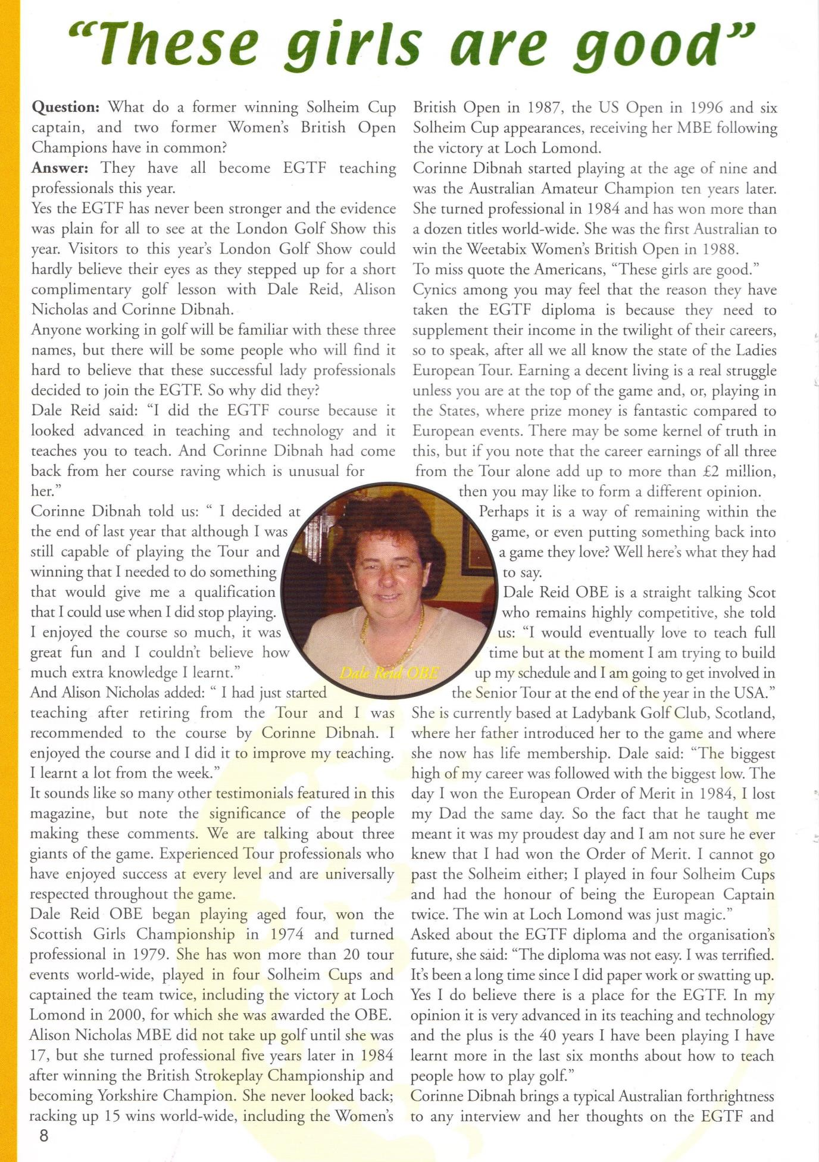
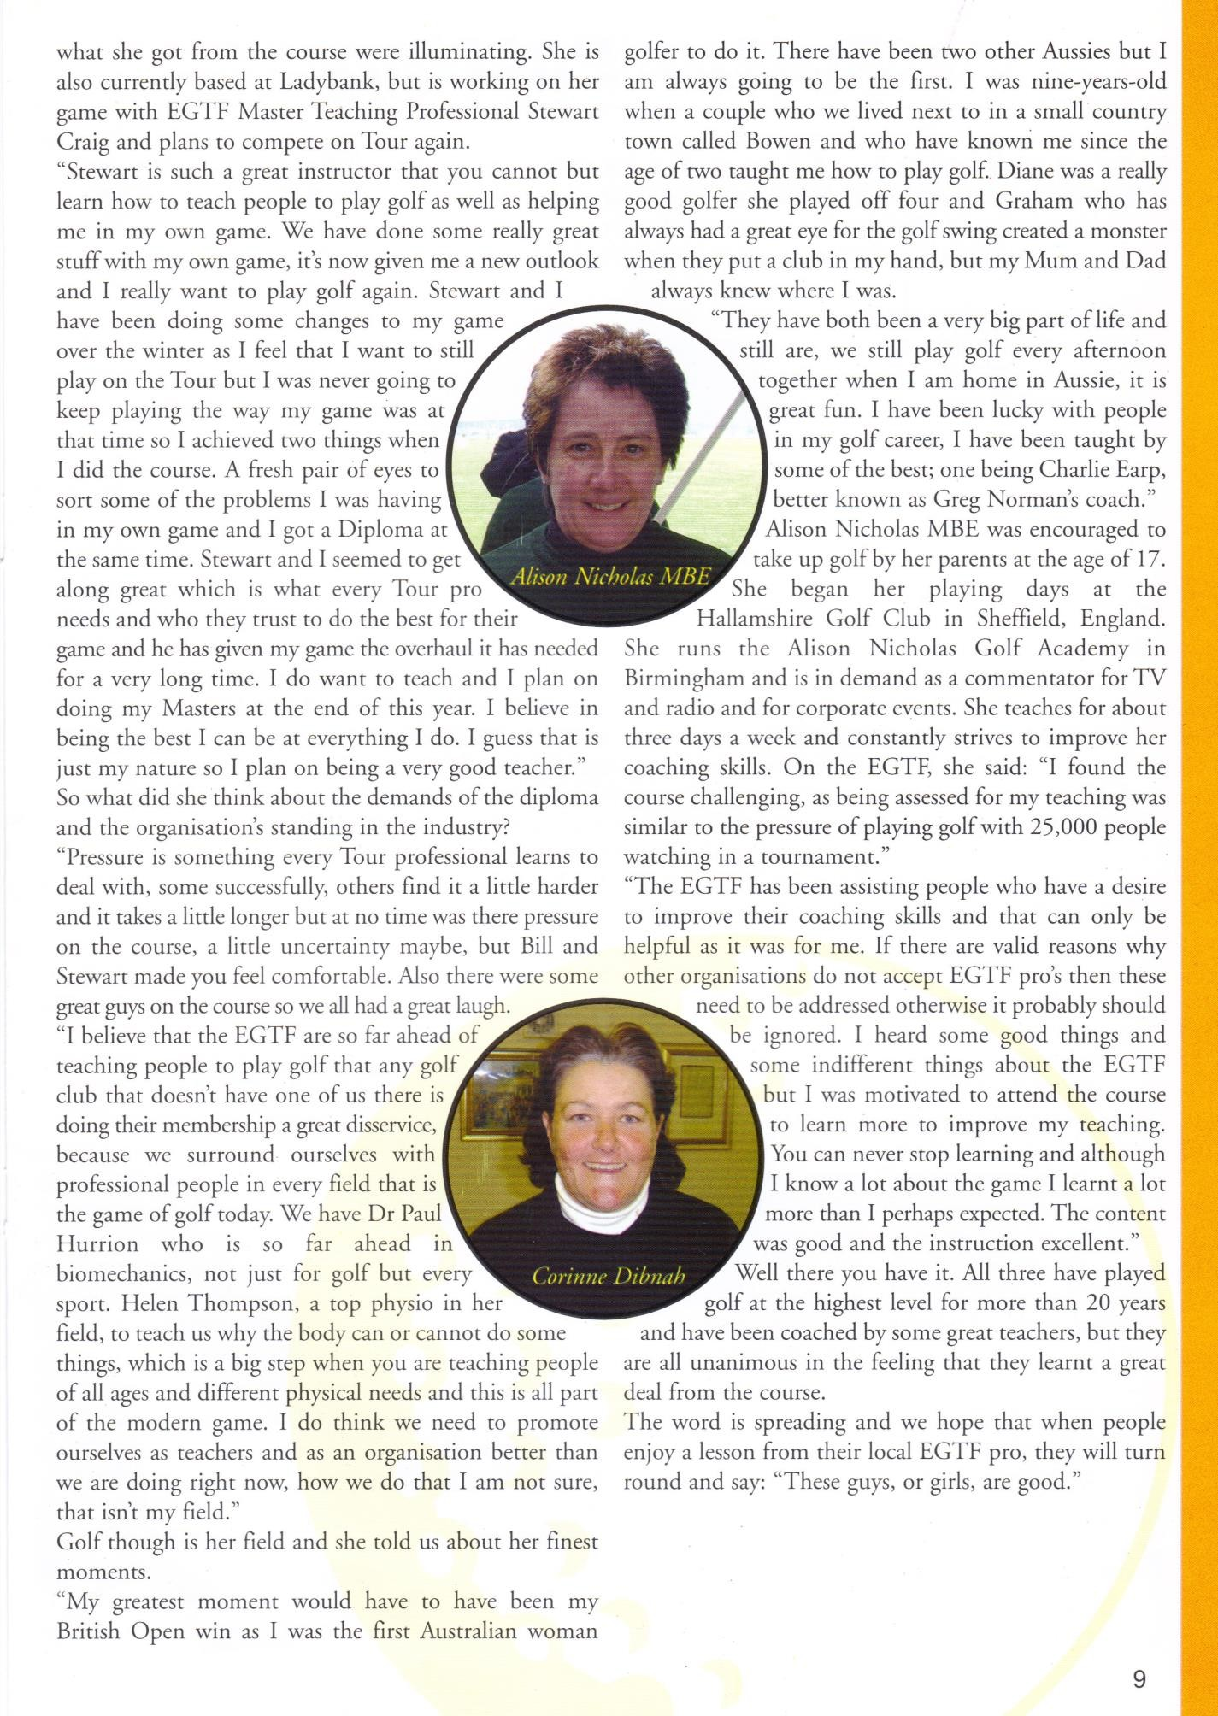

PAYMENT DETAILS

A deposit of £350 gbp (less Membership Fee as Associate Member if applicable) guarantees your place on the course.

Full payment of balance required at the latest 8 weeks before the starting date of the course.

Payment can be made by:

CREDIT/DEBIT CARD PAYMENT:

Payment can be made over the phone or via a Worldpay payment link.

BANK TRANSFER:

Send to TSB, Minehead Branch
Account Name - EGTF
Account No: 25681468
Sort Code: 30-95-66
IBAN: GB19TSBS30956625681468
SWIFT: TSBSGB2AXXX
(Please put your name in the reference)

As always any questions, please do not hesitate to get in touch by phone or email.

EGTF MEMBERS AND BENEFITS

On successful completion of an EGTF residential level 3 diploma course you will automatically become a full member of the EGTF (see member benefits). Those who do not pass all aspects of the course will become an associate member of the EGTF (see member benefits) until such times as all Diploma modules are passed.

FULL MEMBER BENEFITS

• Your acceptance on the Diploma Course of your choice
• Public & Products liability insurance cover £5million (£2million in Northern Ireland)
• Professional Indemnity insurance cover £1 million
• Associate Membership Fees already paid will be deducted from the cost of the
Diploma Course
• You will have Membership only access to the ‘Members Page’ on the EGTF website
• EGTF membership card
• EGTF bag tag
• EGTF pro-am Event schedule
• Preferred rates on golf tuition breaks, equipment and clothing via our corporate partners
• Access to junior development programs

ASSOCIATE MEMBERSHIP BENEFITS

We realise that you may not be able to attend one of the EGTF Diploma Courses at this particular moment, therefore you may be interested in the EGTF Associate Membership Program.
For a yearly membership fee of £60 you can become an Associate Member of the EGTF

• Your acceptance on the Diploma Course of your choice
• Associate Membership Fees already paid will be deducted from the cost of the
Diploma Course
• EGTF membership card
• EGTF bag tag
• Preferred rates on golf tuition breaks, equipment and clothing via our corporate partners

